**TEAM 2**

**FLIGHT RESERVATION SYSTEM**

**LOGIN :**

* In login page, both the user and administrator can login with their corresponding username and password

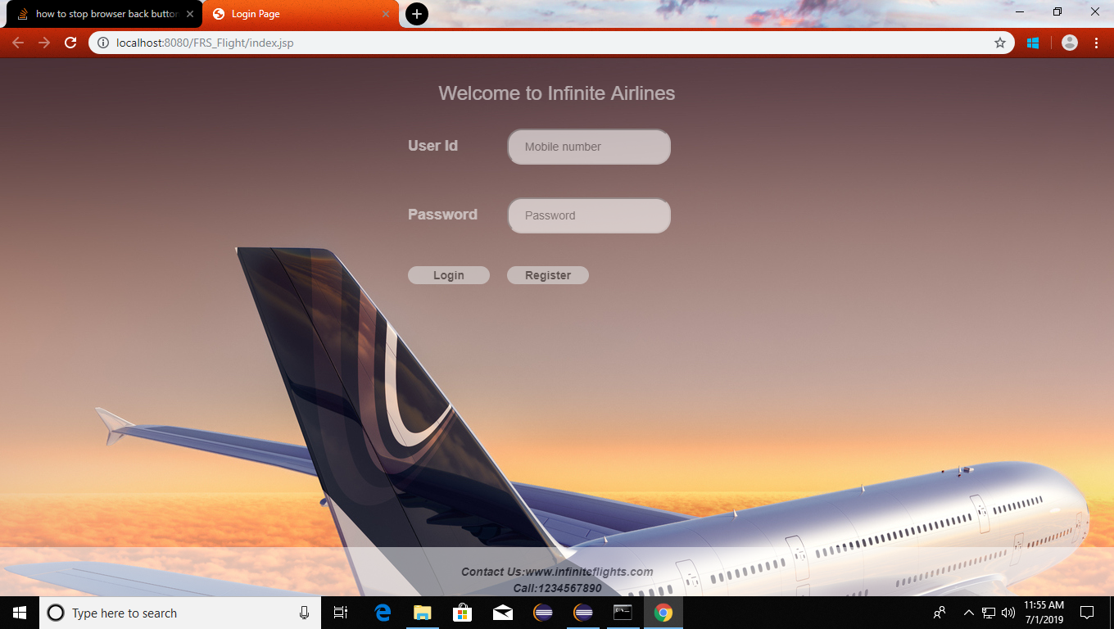

**REGISTER :**

* In registration page, new user can resgiter themselves by filling the required details and they can become registered users.

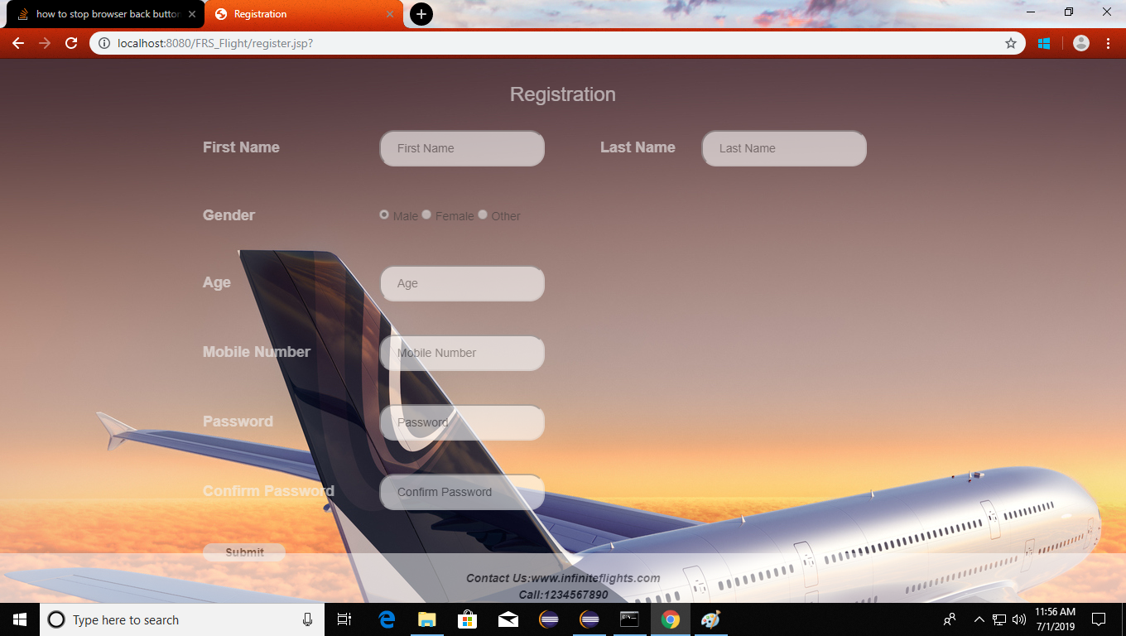

**UPDATING FLIGHT SCHEDULE BY ADMIN :**

* In updation page, Administrator can update the schedule details of the flights which includes the start,destination,arrival time,departure time,date of the travel,name of the flight and cost of the tickets.

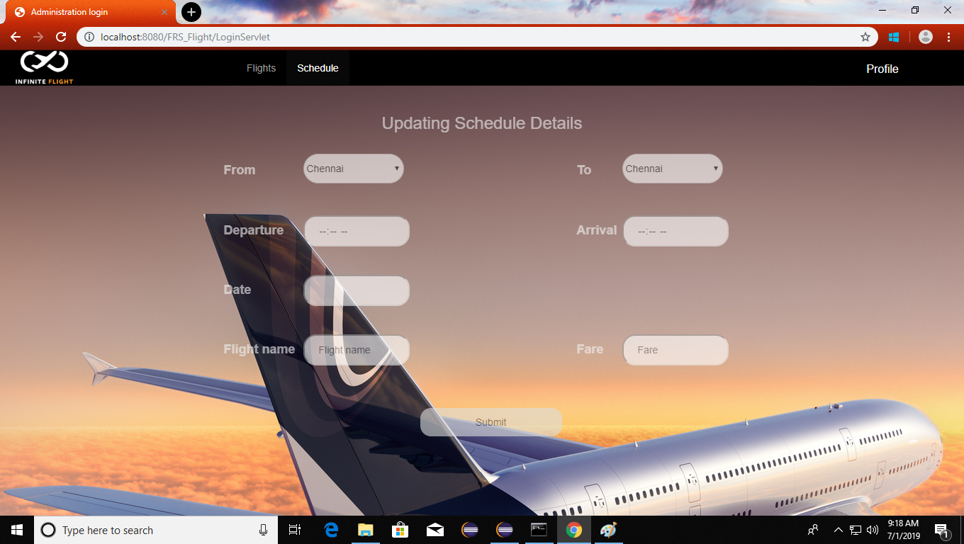

**UPDATION OF FLIGHT DETAILS :**

* In updation page, Administrator can add,delete and modify the dtails of the flight.

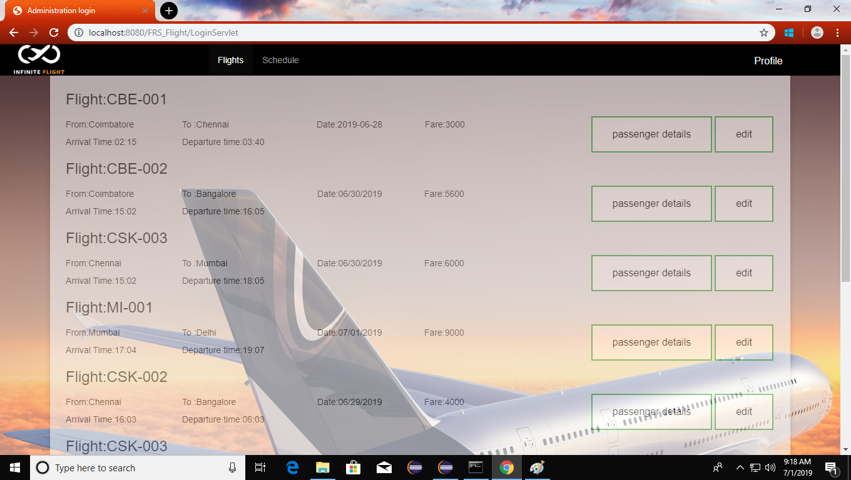

**PASSENGER VIEW OF TICKETS :**

* In view page, the passenger can view the booked tickets which cansists of number of tickeets and the details of the passengers included in the ticket.

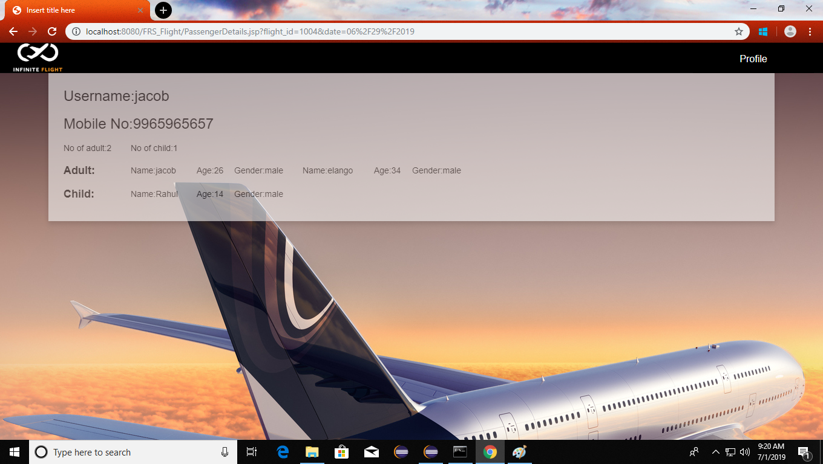

**CHANGE PASSWORD :**

* In change password page, both the administrator and passenger can change the password.

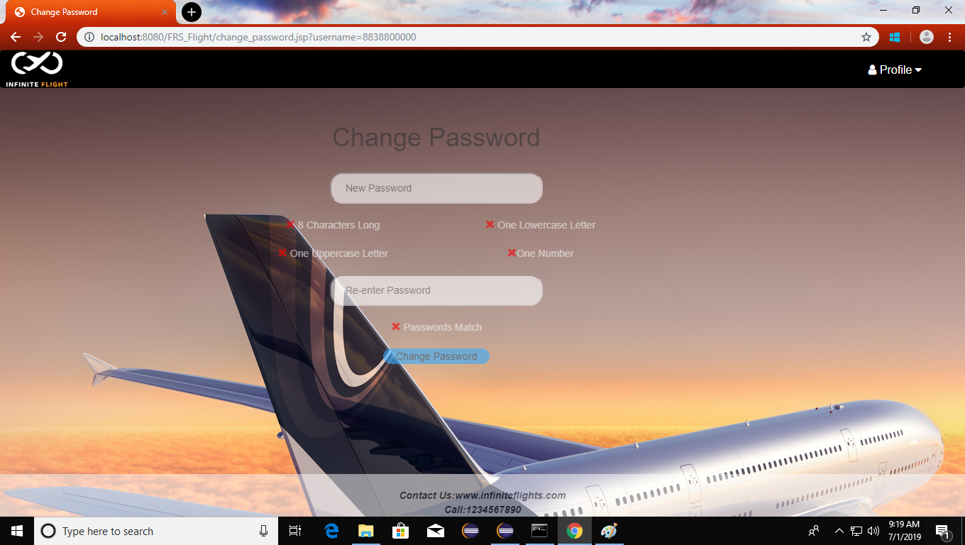

**BOOKING OF TICKET :**

* In booking page, the user can book the tickets by view the list of flight with its corresponding details and can book the tickets.

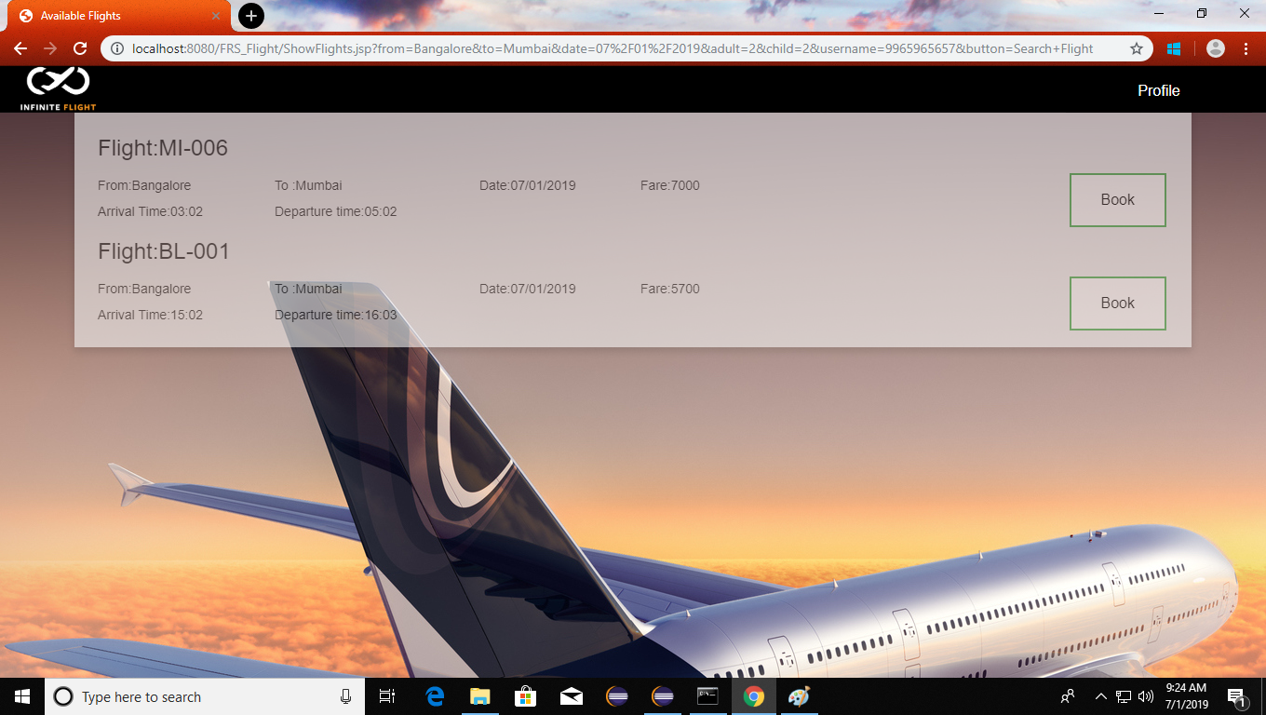

**SEARCHING OF FLIGHT BY PASSENGER :**

* In search page, the user can search the flights for their specification.

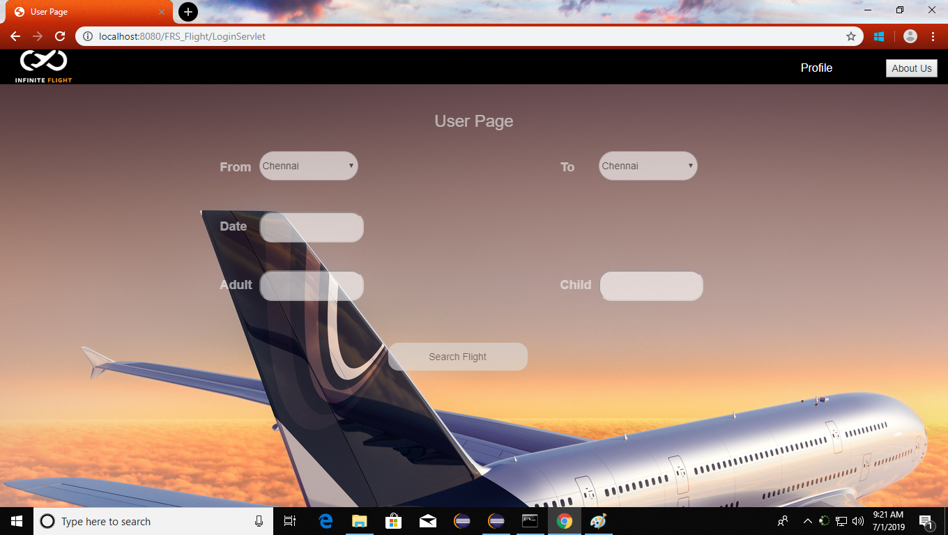

**PASSENGER DETAILS UPDATION BY USER :**

* After booking the tickets, the user should validate the details of the passenger.

